Boomnack FSE User Guide

Installation Instructions:

1. Copy the program folder to a location of your choice.
2. Download and install ‘Love2D’, from [Love2D.org](http://love2d.org).
3. To run the program, drag the program’s folder onto the installed ‘love.exe’.

Description: Our program is a role-playing game (RPG), and as such has the purpose of providing entertainment to players. It is a mix of top-down RPG’s, such as Final Fantasy, and sidescrollers, such as the Mario series.

Instructions:

* After starting the program, you should come to the Intro menu. Press the ‘Play Game’ button to start a new game.
* Now, you can select a potion. This is done by navigating between potions with the left and right buttons, and then pressing the ‘c’ key to select the current potion.
* To go to the next messagebox, press the ‘c’ key.
* Press the escape key when on a map to access the in-game menu.
  + Use the up and down arrow keys to navigate through the menu options.
  + Pressing Resume leaves the menu and goes back to the game.
  + Pressing Quit exits the program.
  + Pressing Items sends you to the Item Select menu (described further down).
  + If you are on the overworld, you are given the option to save the game. There can only be one save file at a time
* When on the Item select menu, you use the up and down keys to navigate to the item you want to use, or the Resume option. You then press the ‘c’ key to either (1) use the current item, or (2) resume the previous state.
* When on a sidescrolling map, you use the left and right arrow keys to move left and right. You can also press the space key to jump. You also use the up arrow key to enter doors and climb ladders.
* When on the overworld map, you use all of the arrow keys to move around.
* When in a battle, you use the up and down arrow keys to navigate to the option you wish to select. You then press the ‘c’ key to select that option. The attack option deals damage to the current enemy. The Flee option makes the player leave the battle without gaining anything. The Items option lets you use an item.

Screen shots:

* Intro menu:  
  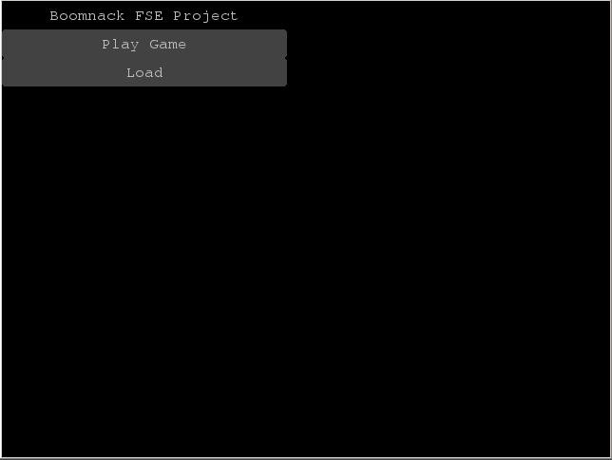
* Sidescrolling stage:  
  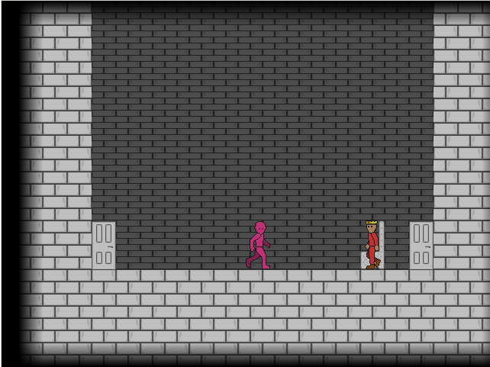
* Overworld stage:  
  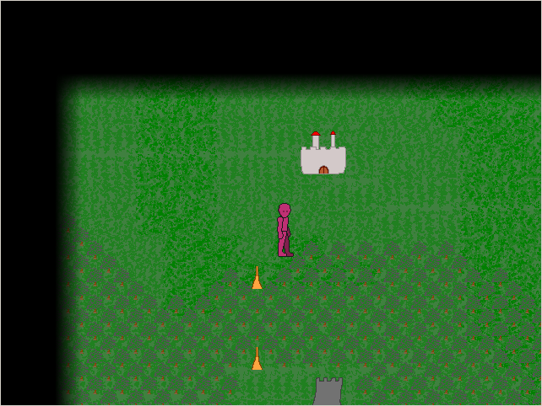
* In-game Menu:  
  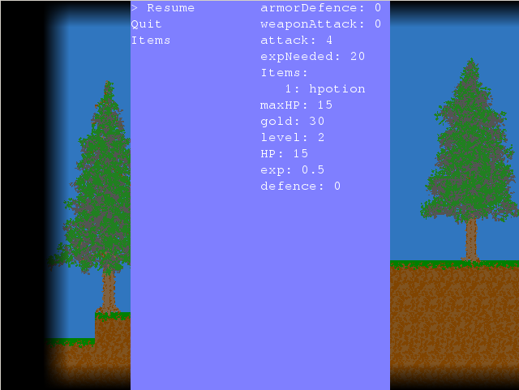
* Item select menu:  
  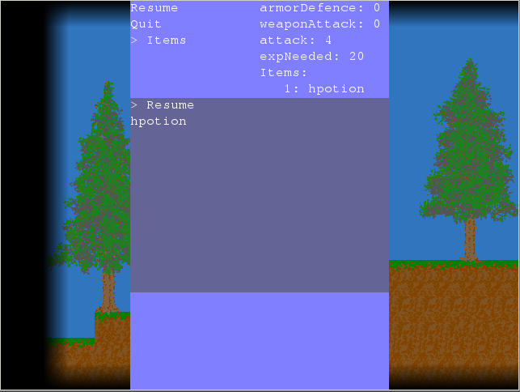
* Battle system:  
  